THE GRANT
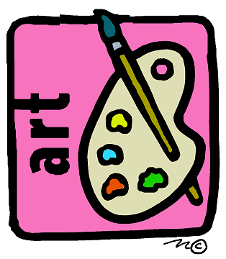
IS
AVAILABLE TO

Individuals aged 15-21 years

Visual, Written, Spoken and Performing Arts

THE GRANT IS AVAILABLE FOR

Equipment – Workshop -
Exhibitions – Performances – Fees
YOU NEED A
SUPPORTER

For Example
A Teacher – Tutor – Kaumatua
To back your application

APPLICATIONS MUST BE SUBMITTED AT LEAST SIX WEEKS BEFORE THE FUNDING IS REQUIRED

For further information about the Youth Arts Fund
contact the Arts Whakatane Secretary
Phone 07 3072315 / 0277226777
e-mail: secretary.artswhakatane@gmail.com
Website Address: www.artswhakatane.co.nz

APPLICATION FORM

NAME OF APPLICANT : Christian: ........................................
Surname: ......................................
RESIDENTIAL ADDRESS: .........................................................
................................................................................................................................................................................................................
PHONE: ..........................................................................................

POSTAL ADDRESS IF DIFFERENT FROM ABOVE:
................................................................................................................................................................................................................
AGE: ............ years DATE OF BIRTH: .........................................

IMPORTANT INFORMATION TO SUPPLY:
- The Arts Discipline you are involved in:
.............................................................................................
- The Amount requested: ....................................................
- Your Supporter’s Name: ....................................................
Address: .............................................................................
Phone: ............................................................................
To accompany this Application Form, give a short written description of how you intend to use the GRANT applied for, and an outline of your achievements making you eligible for the Grant. See the Arts Whakatane website for criteria.
E-Mail documents to the secretary or mail to: Youth Arts Grant, PO. Box 599, Whakatane 3120

